Error Display In List
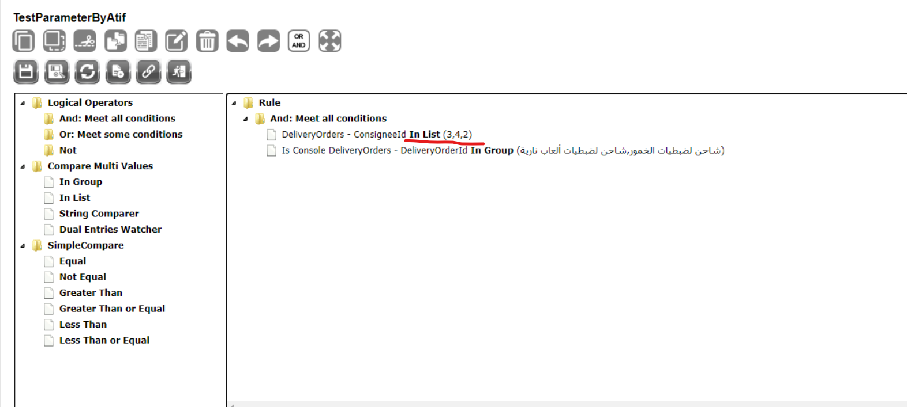
USE [MicroclearLight_July23]
GO

DECLARE @return_value int

EXEC @return_value = [dbo].[Rms_usp_GetDisplayData]
@specificationid = N'427',
@RmsType = N'listCodes',
@Codes = N'3,4,2',
@specProfileid = N'en'

SELECT 'Return Value' = @return_value

GO
Output 0
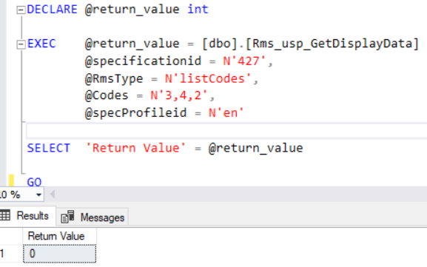

And after Debugging the error in this line gives null in th sp
set @myquery=(select top 1 codedataquery from specprofiles where specprofileid = 1 )
